


Project Executable Files
Date | 02 October 2026
Team ID |  | SWTID-2026-1506
Project Name |  | AI Study Buddy
Maximum Marks | 3 Marks

Project Executable Files
This section requires submission of all executable and deployable files for your project.
Ensure all files are properly organized, named, and uploaded to the specified submission
platform. The evaluator must be able to run or deploy your solution using the provided files
and instructions.
Step 1: Submission Checklist
S.No | Item to Submit | Submitted​ (Yes​ /  No / NA)
1 | Complete source code (all files and folders) | Pending
2 | README / Setup Guide (instructions to run the project) | Pending
3 | requirements.txt / package.json / dependency file | Pending
4 | Database schema / seed files (if applicable) | Pending
5 | similar) | Pending
  Environment​ | configuration​ | file​ | (.env.example​ or
6 | Deployed application URL (if hosted) | Pending
7 | for mobile/desktop apps) | N/A
  APK​ | /​ | Executable​ | binary​ | (if​ | applicable​
8 | Dockerfile / Containerization config (if applicable) | N/A
9 | Test files and test results | Pending
10 | Demo video or walkthrough (if required) | Pending
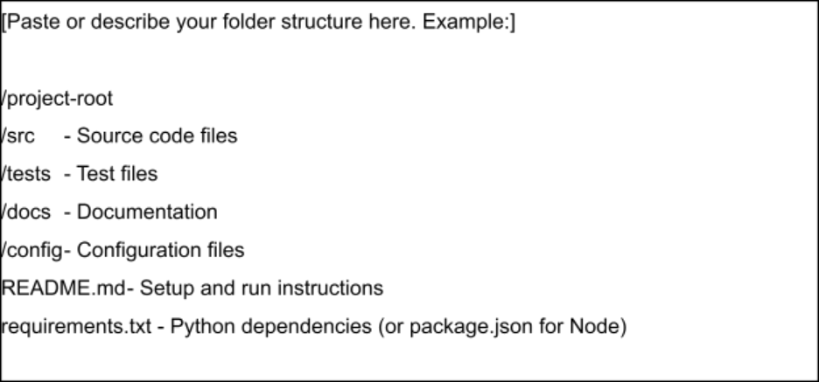

Step 2: File / Folder Structure
Provide an overview of your project's file and folder structure below:
AI-Study-Buddy/ (suggested structure; align names with actual source files)
frontend/ - User interface pages and components
assets/ - Images, icons, and other static resources
styles/ - CSS stylesheets and responsive layout
scripts/ - JavaScript for study-buddy interactions
backend/ - Server/API logic, if used
ai/ - AI prompt or response-handling logic, if used
config/ - Example configuration; keep secrets out of source
tests/ - Test cases and test results
README.md - Setup, usage, and troubleshooting instructions
.env.example - Required environment-variable names, if applicable
Note: The uploaded PDF is a blank template; the actual source tree was not included.

Step 3: Deployment / Access Details
Field | Details
Hosted / Deployed URL | Not provided
Login​ Credentials  (Demo) |  | Not provided
Platform​ | /​ | Hosting

Provider
 |  | Not specified
Repository Link | Not provided
Demo Video Link | Not provided

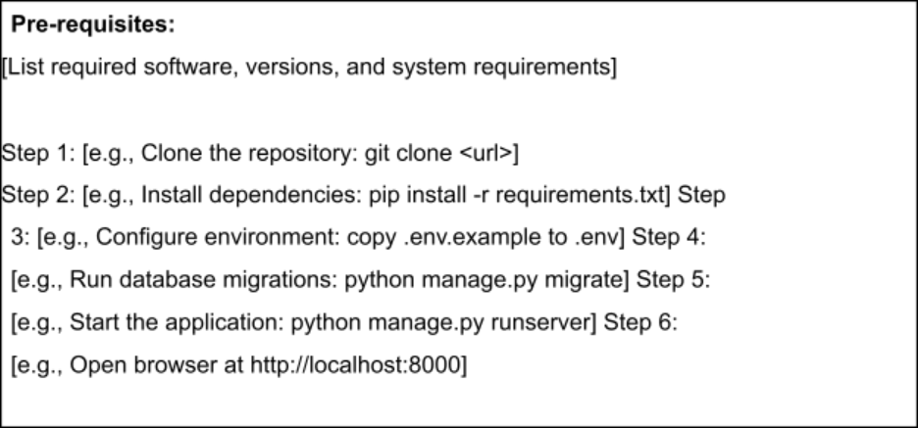

Step 4: Run Instructions
Provide clear, step-by-step instructions for the evaluator to run your project locally:
AI Study Buddy - Local Run Instructions
Pre-requisites:
- Project source folder and its README/setup guide
- A computer with a modern web browser
- Code editor (e.g., Visual Studio Code), if editing source
Step 1: Copy or extract the AI Study Buddy project folder to your computer.
Step 2: Open the folder in your code editor and review README.md.
Step 3: If the project is a static web app, open index.html in a browser
(or use the editor's local preview/live-server feature).
Step 4: If a backend is included, install dependencies using the command
documented in its README (e.g., npm install for a Node.js project).
Step 5: Configure required environment variables using .env.example;
add valid API/database settings only if the requires them.
Step 6: Start the backend using the documented project command, if applicable.
Step 7: Open the local app URL or index page and test the study-buddy features.
Note: Exact commands depend on the submitted source code, which was not
included in the provided PDF template. Do not expose API keys/passwords.

Step 5: Known Issues / Limitations
S.No | Known Issue / Limitation | Workaround / Status
1 | Source code/framework details not included | Confirm against actual project
2 | Deployment URL and demo access not supplied | Add verified links/credentials
3 | AI/API configuration may be required | Follow README; keep secret

